 WASTE MANAGEMENT SYSTEM

# A MINI PROJECT - I REPORT

***Submitted by***

|  |  |
| --- | --- |
| **MATHESH.H.P** | **(2202131)** |
| **PRANESHWARAN.M.S** | **(2202153)** |
| **PRAVEEN.S** | **(2202157)** |

***In partial fulfillment for the award of the degree of***

**BACHELOR OF ENGINEERING**

***in***

**ELECTRONICS AND COMMUNICATION ENGINEERING**

SRI RAMAKRISHNA ENGINEERING COLLEGE

**[Educational Service: SNR Sons Charitable Trust]**

[Autonomous Institution, Accredited by NAAC with „A‟ Grade] [Approved by AICTE and Permanently Affiliated to Anna University, Chennai]

[ISO 9001:2015 Certified and All Eligible Programmes Accredited by NBA] VATTAMALAIPALAYAM, N.G.G.O. COLONY POST, **COIMBATORE – 641 022**

**ANNA UNIVERSITY: CHENNAI - 600025**

# MAY-2024

** SRI RAMAKRISHNA ENGINEERING COLLEGE**

**COIMBATORE – 641 022**

**BONAFIDE CERTIFICATE**

**20EC279- MINI PROJECT 1**

Certified that this 20EC279 - Mini Project - I Report “**FACULTY MANAGEMENT SYSTEM“** is the bonafide work of **Mathesh.H.P (2202131), Praneshwaran.M.S(2202153), Praveen.S(2202157)** who carried out the project under my supervision.

|  |  |
| --- | --- |
|  |  |
| **SIGNATURE** | **SIGNATURE** |
| **Mrs.E.SHANTHINI, M.E.,** | **Dr.M.JAGADEESWARI, M.E., Ph.D.,** |
| **Assistant Professor(S.I.Grade)** | **Professor** |
| **Supervisor** | **Head of the Department** |
| Department of ECE | Department of ECE |
| Sri Ramakrishna Engineering College | Sri Ramakrishna Engineering College |
| Coimbatore- 641 022 | Coimbatore-641 022 |

**Submitted for the Mini Project Viva-Voce Presentation held on 04.05.2024**

|  |  |
| --- | --- |
|  |  |
| **INTERNAL EXAMINER** | **EXTERNAL EXAMINER** |
|  |  |

**­**

# ABSTRACT

# Waste is a commodity that cannot be produced by the economy and plays an important role in the development of the world economy. Waste generation in India is steadily increasing, creating challenges and opportunities for various stakeholders. This article addresses the complexities of waste management in the Indian economy, highlighting its economic impact, environmental impact and ongoing challenges in proper disposal of this plastic waste. The need to reduce negative impacts on the economy and the environment is urgent. Efforts such as plastic bans and waste segregation have been used in the past to control waste. However, despite all these efforts, managing plastic waste is still a challenging process. Work. Relying on the labor-intensive method not only affects the recycling business but also places a heavy burden on the economy. Additionally, the lack of sustainable infrastructure and advanced technology increases the challenges of waste management.

# The use of advanced technologies, such as automated sorting systems and artificial intelligence-based solutions, can simplify waste management, enable recycling and reduce the risk of contamination. In addition, investing in waste management solutions and promoting waste-to-energy measures can create job opportunities while reducing environmental damage. Using waste resources as a useful material or source of energy recovery can realize a circular economy and promote sustainable development. and environmental management. By working together across sectors and stakeholders, India can overcome the challenges of waste management and leverage its transformative resources to create a sustainable environment and thrive in the future.

# Acknowledgment

We put forth our heart and soul to thank **DEBUGGERS** for being with us all through this technical adventure.

We express our heartfelt thanks to our esteemed Managing Trustee, **Sri. D. Lakshmi Narayanaswamy, B.Tech., MBA.,** and Joint Managing Trustee **Thiru. R. Sundar, B.A, MBA.,** for their invaluable support.

We thank our Principal, **Dr. N.R. Alamelu, B.E. (Hons.), M.E., Ph.D., Sri Ramakrishna Engineering College, Coimbatore**, for her benevolent patronage in carrying out this project.

We express our sincere respect and gratitude to our Professor & Head **Dr.M.Jagadeeswari, M.E., Ph.D.,** Department, Electronics and Communication Engineering for her continuous encouragement and motivation throughout the project.

We are indebted to our Mini Project Coordinator **Dr.C.S.Manikandababu, M.E.,** Assistant Professor (Sl.G)and our Supervisor, **Mrs.E.Shanthini,** Assistant Professor(Sl.G) for providing encouragement and guiding us throughout this project with enthusiasm and enabling us to complete it within the stipulated time.

We extend our thanks to all the teaching, non-teaching faculty members of our department and other departments, friends and family members for their support in carrying out the mini-project successfully.

# TABLE OF CONTENTS

|  |  |  |
| --- | --- | --- |
| **CHAPTER NO.** | **TITLE** | **PAGE NO.** |
|  | ABSTRACT | iii |
|  | LIST OF FIGURES | vii |
|  | LIST OF ABBREVATIONS | ix |
| **1** | **INTRODUCTION** | **10** |
|  | 1.1 PROJECT OVERVIEW | 11 |
| **2** | **LITERATURE SURVEY** | **12** |
|  | 2.1 INTRODUCTION | 12 |
|  | 2.2 BACKGROUND | 13 |
|  | 2.3 SUMMARY | 16 |
| **3** | **METHODOLOGY AND WORKING PRINCIPLE** | **17** |
|  | 3.1 PRINCIPLE OF WASTE MANAGEMENT SYSTEM | 17 |
|  | 3.2 WORK FLOW OF THE PROPOSED SYSTEM | 18 |
|  | 3.3 SOFTWARE DESCRIPTION | 19 |
|  | 3.3.1 HTML | 19 |
|  | 3.3.2 CSS | 20 |
|  | 3.3.3 PYTHON | 21 |
|  | 3.4 HARDWARE DESCRIPTION  3.4.1 CONVEYER BELT  3.4.2 CONVEYOR PUSHER  3.4.3 CAMERA  3.4.4 ARDUINO  3.5 VISUAL STUDIO CODE  3.5.1 FEATURES | 22  22  22  23  23  24  25 |
|  | 3.6 UNIQUENESS AND FEATURES | 27 |
|  | 3.7 SUMMARY | 28 |
|  |  |  |

|  |  |  |
| --- | --- | --- |
| **4** | **EXPERIMENTAL RESULTS AND DISCUSSION** | **29** |
|  | 4.1 RESULT FOR PLASTC DETECTION | 29 |
| **5** | **CONCLUSION AND FUTURE SCOPE** | **32** |
|  | 5.1 CONCLUSION | 32 |
|  | 5.2 FUTURE ENHANCEMENT | 33 |
|  | **REFERENCES** | **36** |

**LIST OF FIGURES**

|  |  |  |
| --- | --- | --- |
| **FIGURE NO.** | **TITLE** | **PAGE NO.** |
| 3.1 | Block Diagram of the Work flow | 18 |
| 3.2 | HTML sample programming | 26 |
| 3.3 | HTML sample programming | 27 |
| 4.1 | A website using HTML to display the output | 29 |
| 4.2 | Select a image with plastic for detection | 30 |
| 4.3 | AI detects the plastic in that image | 30 |
| 4.4 | Selecting a image without plastic for detection | 31 |
| 4.5 | AI detects no plastic in that image | 31 |

**LIST OF ABBREVATIONS**

|  |  |
| --- | --- |
| PWM | Pulse Width Modulation |
| AI | Artificial Intelligence |
| YOLO | You Only Look Once |
| HTML | Hypertext Markup Language |
| CSS | Cascading Style Sheet |
| DSP | Digital Signal Processing |
| PCB | Printed Circuit Board |
| IDE | Integrated Development Environment |

# CHAPTER 1 INTRODUCTION

Science and technology are changing day by day and automation is entering every aspect of daily life and appears everywhere. However, these technological developments are accompanied by increasing environmental pollution, especially the increase in plastic waste worldwide. This unfortunate situation underlines the urgent need for new solutions to address environmental degradation and promote sustainable practices, especially in the field of waste management.

Transformation is possible by using technology to change the way society deals with and manages waste. Just as smart window automation increases comfort and energy efficiency in homes and offices, smart waste management systems promise to redefine the meaning of waste disposal and recycling. Most of the problems arise from poor disposal systems and inadequate infrastructure. Traditional waste management methods have proven insufficient to solve the problem of waste generation that causes environmental pollution and damage. These systems include data analytics, time management systems and IoT connectivity to optimize waste, identify processes and recycle. Just as smart windows provide personalization and unprecedented comfort, smart waste management systems allow users to improve waste disposal processes and reduce environmental impact. Improving waste collection and recycling strategies will be renewed, including advanced waste monitoring, smart devices with Wi-Fi connectivity and data analysis techniques. These systems, which automate and optimize the waste management process, not only increase efficiency but also contribute to the sustainability of the environment by reducing pollution and saving resources. Various needs, including family, urban needs. These systems for families allow individuals to participate in waste reduction by providing user interaction and personalized solutions. Smart waste management systems for businesses and municipalities provide data-driven insights and efficiencies that enable effective management strategies and cost savings.

# PROJECT OVERVIEW

# The rapid increase in the world's plastic waste production, exacerbated by inadequate waste management infrastructure, demonstrates the urgent need for new solutions to reduce the circulation of environmental degradation and promote culture. Taking action is an important step to solve the increasing environmental pollution problems of the 22nd century and promote sustainable practices. Harnessing the power of technology, these systems have the potential to revolutionize waste management, promote environmental stewardship and create a cleaner, safer environment for future generations.

# The technology was combined with Arduino-based hardware to create a system that can identify plastic waste in different wastewater streams. Key goals include improving recycling practices, reducing pollution and promoting recycling practices for a safer, greener future. overcome Our system leverages the state-of-the-art YOLO product detection algorithm combined with Arduino-based hardware to provide a new way to quickly and accurately identify plastic waste in multiple wastewater streams. Using the identification and separation process, our solutions not only increase the recycling of materials but also reduce contamination problems, thus contributing to ensuring environmental stability and promoting a clean, green future.

# CHAPTER 2

# LITERATURE SURVEY

# The manufacturing process requires a lot of research on existing processes and emerging technologies. Many research papers have been done on different articles and discussion papers to get the best results. This was done to collect information about the data set and waste level management technologies.

# INTRODUCTION

Waste is part of the economy; It is a product (output) of the economy, government and family. Waste also forms an input into the economy through material or energy recovery. Waste generation in India has been increasing steadily over time. Managing this waste has financial consequences on productivity, government spending and, of course, the environment.

Although attempts have been made in the past to implement plastic bans and separate waste by type, managing plastic waste remains an ongoing challenge. Inefficient manual verification processes often lead to contamination that hinders recycling.  The system can be sent to municipal waste collection centers for efficient and effective distribution of plastic waste. This innovation not only reduces environmental pollution, but also encourages recycling practices, leading to a cleaner, greener future.

# BACKGROUND

# Yang, L., “IEEE Transactions on Environmental Informatics”, A Comprehensive Review of AI Applications in Plastic Waste Management

Yang provides a comprehensive review of various AI techniques in plastic waste management. Covering a range of technologies, from computer vision to machine learning, the review provides insight into the continuing evolution of technology to deal with waste. Yang's comprehensive review provides insight into the use of AI in plastic waste management, from computer vision to machine learning.

However, further research on the challenges of realworld applications could be utilized to guide future research in developing practical strategies. Specific details of application issues. Future research should focus on addressing performance issues for successful referrals. This review highlights the role of AI in plastic waste management, but lacks a deeper understanding of real-world applications and requires further research.

# Gupta, S. “IEEE Transactions on Industrial Electronics”, Limitations of Current Plastic Sorting Systems: A Critical Analysis 2023

Gupta analyzes the limitations of the current plastic system, highlighting problems such as misclassification and failure to control certain types of plastic. Future research should focus on developing hybrid models that can perform well on different plastics.

The article provides suggestions for improving accuracy and adaptability, recommends the development of hybrid sorting models that can process different plastic materials, and encourages future research in this direction.

# Chen, W, “IEEE Transactions on Human-Machine Systems”, Human-Centric Design in AI-Enhanced Waste Sorting Systems, 2023

Chen emphasized the importance of human design in AI-enhanced waste sorting systems. This article discusses the role of user interface, user experience, and user feedback in the optimization and validation of these systems. Although the document supports human design, it does not provide specific designs. Future research should focus on developing methods for designing social user interfaces and engaging with effective user input. . However, when expressed this way, paper does not have a specific design. Future research should focus on developing a process that will enable a better understanding of the communication and integration of users' suggestions, thereby increasing the value efficiency and validity of these systems in real environments.

# Gupta, S. “Limitations of Current Plastic Sorting Systems: A Critical Analysis”, 2023

# Gupta reviewed the limitations of the current plastic classification system, highlighting problems such as misclassification and failure to control certain types of plastic. The article shows the need to improve the accuracy and adaptability of the plastic sorting machine. Future research should focus on developing hybrid models that can perform well on different plastics. Feedback increases the accuracy and adaptability of the classification process to solve these problems. He suggests that future research directions should focus on developing hybrid models that can manage different plastic materials, thereby increasing the efficiency and usefulness of plastic waste separation technologies.

# Zhang, Y , “IEEE Transactions on Industrial Informatics”, Integration of Machine Learning and Edge Computing for Real-Time Plastic Waste Recognition,2022

Zhang is exploring the combination of machine learning and informatics to make plastic waste more visible. The paper demonstrates the benefits of processing edge data to speed up the processing of plastic waste. This article highlights the benefits of edge computing but does not address the resources and challenges associated with edge computing.  
 Combining machine learning with edge computing enables instant plastic waste analysis, highlighting potential speed and efficiency improvements. However, the article lacks an indepth study of potential inefficiencies and problems associated with the use of financial resources and suggests that future research is needed to complete these details.

# SUMMARY

Together, our waste management practices are an important step in solving the problem of waste production and waste in our societies. We have developed a number of programs to promote sustainable waste management and identify key areas that can be improved through indepth research and implementation. Environmental management of our overall environmental impact.

In addition to improving waste management, our work also brings social participation and environmental awareness. However, there are still problems to be solved in ongoing research into effective waste management. Going forward, continued collaboration and creativity is required to ensure long-term growth.

# CHAPTER 3 METHODOLOGY AND WORKING PRINCIPLE

Our aim is to propose a method to achieve the following -:

* Reduce the dumping of plastic waste
* Less pollution to the land and nature
* Automate the process of plastic waste management

# PRINCIPLE OF WASTE MANAGEMENT SYSTEM

The basis of waste management is the principles of sustainability and environmental management. This principle requires an effective waste management approach that focuses on minimizing waste generation, maximizing efficiency and improving health. The basis of this principle is the concept of waste hierarchy, in which actions such as reducing, reusing, recycling, recovering energy and disposing accordingly are prioritized. By emphasizing the importance of waste prevention through education and awareness campaigns, encouraging the recycling of materials to extend their life, and utilizing recycling services to recover resource value, your project aims to reduce the impact of waste on the environment while creating a positive impact. in life.  Develop a culture of environmental responsibility in the company. Additionally, your project demonstrates the importance of collaboration between stakeholders such as local governments, businesses and residents to jointly solve technical problems and drive change for the future. Through innovation, learning and collaboration, your project aims to achieve the transition to a circular economy that reduces waste, preserves resources and emphasizes the clean environment of healthy drinks.

# WORK FLOW OF THE PROPOSED SYSTEM

The Waste Management Project is a key intersection of technology and environmental sustainability, using innovative solutions to solve complex problems such as waste generation, disposal and recycling. The basis of the project is a good way to change the culture of society. Starting with research and analysis, the project team has a deep understanding of the complexities of current waste management. This phase requires a comprehensive assessment of waste, production costs and existing processes. Through these efforts, key areas for improvement were identified, which formed the basis for setting goals and objectives. The next phase of planning and execution marked the move into action. Numerous initiatives are being created and implemented here, from recycling programs to compost facilities to wastewater reduction. Collaboration with local governments, businesses and community organizations makes it easier to pool resources and expertise to increase the impact of the project. The basis of a successful project is the integration of technological processes. A professional conveyor equipped with separators and distributors to ensure the disposal of waste. Using cameras combined with machine learning algorithms like YOLO can achieve unprecedented results in instant garbage classification. This automated decision-making process simplifies operations, reduces human intervention and increases efficiency. Moreover, the program is particularly important for the collection of plastic bottles due to their huge impact on the environment and the recognition of their recycling possibilities. The program helps reduce plastic pollution and promote circular business models by emphasizing the diversion of this material from landfills. Ongoing monitoring and evaluation tools are used to track progress and measure impact throughout the project. Maintain coordination with stakeholders and community feedback to ensure the project remains flexible and aligns with needs and priorities. Efforts to promote education are at the heart of the entire program, raising awareness and changing the behavior of residents and businesses. Promote best waste management through education, debate and public awareness and encourage participation in sustainable development projects. There will be a special moment of reflection when a project comes to an end. Lessons learned, achievements celebrated, and plans developed to continue and expand the project. By following these best practices, waste management programs not only solve immediate problems but also foster long-term change, leading to safer, stronger communities.

# 

# Fig 3.1 BLOCK DIAGRAM OF THE WORK FLOW

* 1. **SOFTWARE DESCRIPTION**

# HTML :

HTML, proposed by Tim Berners-Lee in 1989, debuted as HTML 1.0 in 1993 for sharing documents online. It evolved through versions like HTML 2.0 (1995) and HTML 4.01 (1999), introducing features such as forms and multimedia support. HTML5, launched in 2014, revolutionized web development with new semantic elements and enhanced multimedia capabilities. It continues to evolve to improve compatibility across devices and browsers, reflecting the dynamic nature of the web. HTML, which stands for HyperText Markup Language, is the standard language used to create and design web pages. It provides a structured way to organize and format content on the internet. HTML uses a system of tags to define the structure and layout of a web page. These tags are enclosed in angle brackets <> and come in pairs, with an opening tag and a closing tag, surrounding the content they affect. For example, `<p>` is the opening tag for a paragraph, and `</p>` is the closing tag. HTML allows you to create headings, paragraphs, lists, links, images, forms, and much more. It provides a foundation upon which other web technologies, such as CSS (Cascading Style Sheets) and JavaScript, can be built upon to enhance the design and functionality of a website. In summary, HTML is the backbone of web development, providing the structure and organization necessary for creating and displaying content on the internet. HTML documents consist of elements, each with its own purpose and meaning, such as headers, navigation menus, and footers. These elements can be styled and manipulated using CSS to enhance their appearance and layout. HTML5, the latest version of HTML, introduces new features like native video and audio support, semantic elements for clearer markup, and enhanced form controls for better user experience. Understanding HTML is essential for anyone interested in web development, as it serves as the foundation for building interactive and engaging websites. With its simplicity and versatility, HTML remains a fundamental skill for creating content on the World Wide Web.

# Features

* + - * Structure: HTML provides a structured format for creating web pages by using elements such as headings, paragraphs, lists, and links. These elements define the content and layout of a web page, making it easy to organize and present information.
      * Semantic Markup: HTML supports semantic markup, allowing developers to use tags that convey the meaning and purpose of the content. Semantic elements like `<header>`, `<footer>`, `<nav>`, and `<article>` provide clarity and improve accessibility for both users and search engines.
      * Multimedia Integration: HTML enables the integration of multimedia elements such as images, videos, and audio into web pages using tags like `<img>`, `<video>`, and `<audio>`. This allows for rich and interactive content that enhances user experience.
      * Forms and Input Controls: HTML includes form elements such as `<form>`, `<input>`, `<textarea>`, and `<button>` for creating interactive forms and capturing user input. These elements facilitate user interaction, data submission, and feedback collection on web pages.
      * Accessibility: HTML supports accessibility features such as alt attributes for images, tab index for keyboard navigation, and semantic markup for screen readers. By adhering to accessibility best practices, developers can ensure that web content is usable and accessible to users with disabilities.

# CSS :

# CSS, short for Cascading Style Sheets, is a fundamental technology used to define the presentation and layout of web pages written in HTML and XHTML. It provides a mechanism for separating document structure (HTML) from presentation aspects (styling), allowing developers to style web pages with precision and consistency.

# One of the key features of CSS is its ability to control the visual appearance of HTML elements, including text, colors, fonts, spacing, and positioning. CSS achieves this through a set of rules that target HTML elements and apply styling properties to them. These rules consist of selectors that specify which elements to style and declarations that define the styling properties to be applied.

# CSS offers various selectors to target HTML elements based on their type, class, ID, attributes, and relationship to other elements in the document. This flexibility allows developers to apply styles selectively and efficiently, ensuring a consistent and cohesive design across web pages.

# Furthermore, CSS supports inheritance and cascading, which are essential principles that determine how styles are applied and overridden. Inheritance enables child elements to inherit styles from their parent elements, reducing the need for redundant styling rules. Cascading refers to the process of resolving conflicts when multiple CSS rules target the same element, with specificity and source order playing a crucial role in determining which styles take precedence.

# In addition to basic styling properties like color, font, and margin, CSS also offers advanced features such as transitions, animations, and flexbox/grid layouts, enabling developers to create visually rich and interactive web experiences.

# Overall, CSS is a powerful styling language that complements HTML, allowing developers to create well-designed and visually appealing web pages that are responsive, accessible, and user-friendly.

# PYTHON :

# Python is a versatile and powerful programming language known for its simplicity, readability, and flexibility. It was created by Guido van Rossum and first released in 1991, with an emphasis on code readability and a clear, expressive syntax. Python is widely used in various domains, including web development, data science, artificial intelligence, scientific computing, and automation.

# One of Python's key features is its easy-to-understand syntax, which makes it accessible to beginners and experienced developers alike. Python code is typically concise and expressive, allowing developers to accomplish complex tasks with minimal lines of code. This readability contributes to faster development cycles and easier maintenance of codebases.

# Python supports multiple programming paradigms, including procedural, object-oriented, and functional programming styles. This versatility enables developers to choose the most suitable approach for their specific needs and preferences. Python's object-oriented features facilitate code organization and reuse, while its functional programming capabilities allow for elegant solutions to problems involving data manipulation and transformation.

# Moreover, Python boasts a rich ecosystem of libraries and frameworks that extend its functionality and enable developers to build a wide range of applications efficiently. Libraries like NumPy, pandas, and Matplotlib are popular choices for data analysis and visualization, while frameworks like Django and Flask are widely used for web development.

# Additionally, Python's extensive standard library provides built-in modules and functions for tasks such as file I/O, networking, regular expressions, and more, further enhancing its capabilities and reducing the need for external dependencies.

# Overall, Python's simplicity, readability, versatility, and extensive ecosystem make it a preferred choice for developers seeking to build scalable, maintainable, and high-performance software solutions across diverse domains.

# 3.4 HARDWARE DESCRIPTION:

# 3.4.1Conveyor Belts: Conveyor Belts are an important material handling equipment and are widely used in many industries, from manufacturing to transportation and waste management. Conveyors use conveyor belts made of durable materials that help move goods from one place to another, speeding up the process and making it more efficient. In waste management projects, conveyors are the main means of transporting waste for separation and processing.

**3.4.2 Conveyor** **Pushers:** Conveyor Pushers are mechanical devices integrated into conveyor systems that assist in material handling and identification. Conveyor pushers, usually powered by motors or actuators, use control power to move material along a conveyor belt according to a predetermined process. In waste management, conveyor pushers play an important role in taking waste to the designated location for segregation and processing.

**3.4.3 Cameras**:  
 Cameras are an important part of technology that uses recommended techniques for tracking time, analysis and decision making. In waste management projects, cameras are often used to capture images or video footage of waste. These images are then processed using computer vision algorithms to analyze and categorize the data, thus facilitating classification and processing. Cameras capture waste with high speed and accuracy, increasing the efficiency and reliability of waste management.

**3.4.4 Arduino**:  
 Arduino is an open source electronic device known for its ease of use and ease of use in building systems and IoT (Internet of Things) applications. Arduino features a microcontroller board and a user-friendly integrated development environment (IDE) that allows developers to create solutions for a variety of tasks, including controlling the electricity of devices. In waste management, Arduino boards are often used to control various components such as conveyor systems, sensors, actuators and data processing. By connecting to sensors and actuators, Arduino enables smart decision-making and automation, making waste management processes more efficient and effective.

* 1. **SOFTWARE DESCRIPTION**
     1. **VISUAL STUDIO CODE**

Visual Studio Code (VS Code) is a lightweight yet powerful code editor developed by Microsoft. Its excellent design, performance, and user-friendliness make it a popular choice for developers across many programming languages ​​and platforms. One of its best features is its versatility, providing support for many programming languages ​​through extensions, thus enhancing its functionality to meet the needs of the developer. It allows developers to focus on their rights without unnecessary distractions. Its interface includes features such as a file browser, an integrated terminal, and a variety of customization options and color schemes that allow developers to customize the coding environment for themselves. Additionally, VS Code has Git integration for seamless version control right in the editor. These extensions are available in the Visual Studio Code Marketplace and provide additional features such as language support, debugging tools, code snippets, and integration with various development programs and services. Developers can easily install and manage extensions to customize the experience and improve workflow, allowing VS Code to adapt to different tasks and workflows. Debugging capabilities for languages ​​such as JavaScript, Python, and C#. Developers can set breakpoints, analyze variables, and push code directly in the editor to resolve issues and usability issues. This integrated problem-solving approach is more efficient and helps developers better identify and solve problems.

* + 1. **FEAUTURES**
       - Visual Studio Code (VS Code) boasts a plethora of features that cater to the needs of developers across various programming languages and workflows. Here are some of its key features:
       - **Cross-Platform Support**: VS Code is available on Windows, macOS, and Linux, ensuring a consistent experience across different operating systems.
       - **Intuitive Interface**: Its clean and intuitive interface provides a distraction-free environment for coding, with features like a file explorer, integrated terminal, and customizable layouts.
       - **Extensibility**: VS Code's rich ecosystem of extensions allows developers to enhance its functionality with support for additional languages, debugging tools, themes, and more. The Visual Studio Code Marketplace offers thousands of extensions created by the community.
       - **Integrated Development Environment (IDE) Features**: Despite being lightweight, VS Code offers powerful IDE-like features such as code autocompletion, syntax highlighting, code snippets, and IntelliSense, which provides context-aware suggestions.
       - **Built-in Git Integration**: VS Code includes built-in Git integration, enabling version control operations such as commit, push, pull, and merge directly within the editor. It also provides visual indicators for changes and conflicts in the code.
       - **Debugging Tools**:VS Code offers built-in debugging support for various programming languages, allowing developers to set breakpoints, inspect variables, and step through code to troubleshoot and debug their applications efficiently.
       - **Terminal Integration**: The integrated terminal allows developers to run commands, scripts, and terminal-based tools directly within VS Code, eliminating the need to switch between the editor and a separate terminal window.
       - **Customization**: VS Code is highly customizable, allowing users to personalize their editing experience by configuring settings, keybindings, and themes. Users can also create their own extensions or contribute to existing ones to extend VS Code's functionality.
       - **Task Automation**:VS Code supports task automation through its integrated task runner, allowing developers to define and execute tasks such as build scripts, test suites, and deployment processes directly from the editor.
       - **Collaboration**: With features like Live Share, developers can collaborate in real-time with teammates, enabling shared editing sessions, code reviews, and debugging sessions across different locations.
       - These features, along with its lightweight nature and active community support, make Visual Studio Code a popular choice among developers for writing, debugging, and collaborating on code across a wide range of programming languages and projects.

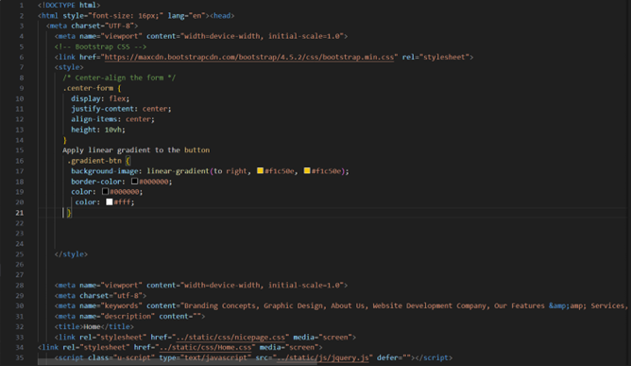

# Fig 3.2 HTML SAMPLE CODING

# 

**Fig 3.3 HTML SAMPLE CODING**

* 1. **UNIQUENESS AND FEATURES**
* **IoT Integration**: Utilizing Internet of Things (IoT) sensors to monitor waste levels in real-time, ensuring efficient collection schedules.
* **Data Analytics**: Employing advanced analytics to analyze waste generation patterns, optimize collection routes, and minimize operational costs.
* **Smart Routing Algorithms**: Implementing intelligent routing algorithms to optimize collection routes dynamically, considering factors such as traffic conditions and bin fill levels.
* **Environmental Impact Reduction** : Aiming to reduce environmental impact by minimizing unnecessary waste collection trips and optimizing resource utilization.
* **Long-Term Sustainability** : Supporting long-term sustainability goals by promoting efficient resource utilization, reducing carbon footprint, and improving overall waste management practices.

# SUMMARY

# This section provides a brief overview of the methods adopted during the implementation of waste management. It describes the main elements used, such as conveyor belts, dispensers, conveyor belt pushers, camera systems and Arduino microcontrollers, and explains their functions and roles in the operation of the system. The equipment involved during use is discussed and their contribution to all functions of the  body is clarified. From conveyors that facilitate the movement of waste to camera systems that capture and sort data, all equipment plays an important role in improving waste management and operation. About the importance of logic programs, especially in the context of Arduino microcontrollers. Software products increase the efficiency and effectiveness of systems by communicating between hardware devices and enabling efficient decisionmaking. Through clear and concise explanations, readers can gain a deeper understanding of the hardware and software and provide a basis for further research and analysis of  the system and operation

# CHAPTER 4

# EXPERIMENTAL RESULTS AND DISCUSSIONS

This project has successfully overcome the problem of detection and confirmation of plastics and non-plastics. The result of the detection also will be shown in the Figure. Thus the plastics can be separated. The product development process requires a large survey of existing methods and growing technology. Various literature surveys from different journals and conference paper has been studied for best results. This has been done to collect information about the dataset and waste level controlling techniques.

# RESULT FOR PLASTIC DETECTION:

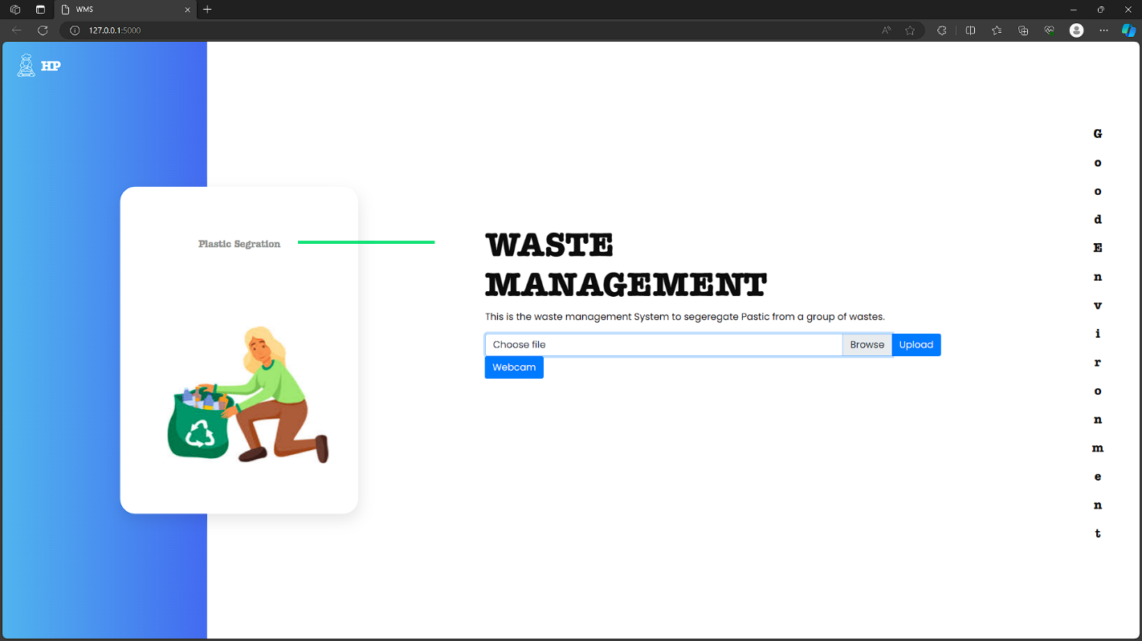

**Figure 4.1 A website using HTML to display the output**

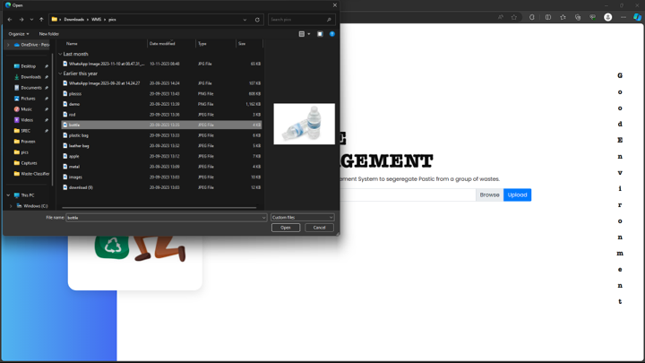

# Figure 4.2 Selecting a image with PLASTIC for DETECTION

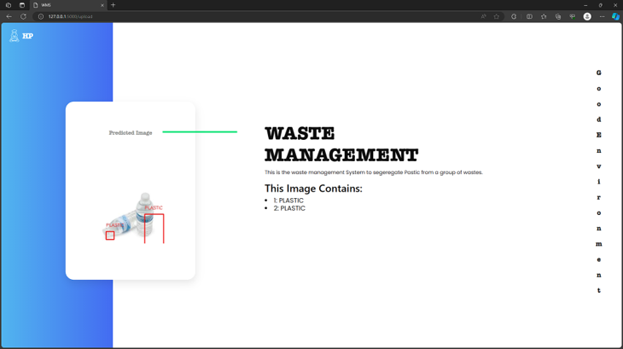

# 

# Figure 4.3 AI detects the plastics in that image

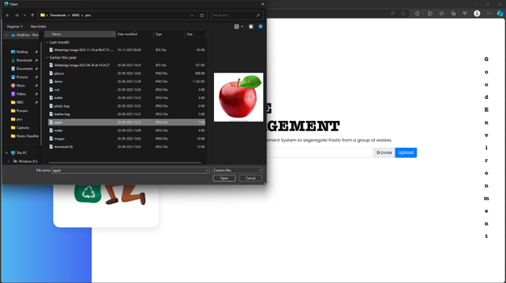

# Figure 4.4 Selecting a image without PLASTIC for

# DETECTION

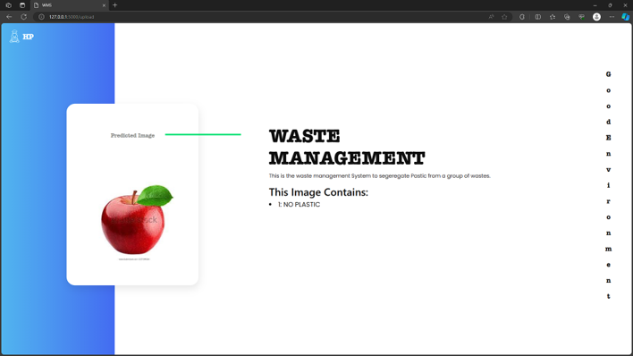

# Figure 4.5 AI detects that no plastics in that image

# CHAPTER 5

# CONCLUSION AND FUTURE SCOPE

* 1. **CONCLUSION**

Together, our waste management programs are critical to solving the ongoing problem of waste production and disposal in our communities. With a comprehensive approach that includes in-depth research, strategic planning and collaboration, we have achieved significant results in sustainable waste management. Implement key areas and strategic solutions to improve waste disposal, segregation and recycling processes. By using new technologies such as artificial intelligence, IoT devices and data analysis, we not only improve waste management but also reduce our space. Engage with members, businesses and local authorities to promote a culture of environmental awareness. By engaging stakeholders in the decision-making process and building support for waste reduction measures, we have created a solid foundation for a vision of long-term sustainability and environmental control. It is true that the road to good waste management is still a long way off. Continuous collaboration, innovation and change are essential to solve emerging challenges and embrace new opportunities in the dynamic field of waste management. The transformative impact of innovation in solving complex environmental problems. By working together on common goals, we dream of a clean, environmentally friendly and sustainable future.

# FUTURE ENHANCEMENT

# In envisioning future enhancements for our waste management project, the integration of IoT devices emerges as a cornerstone advancement. These devices would enable real-time monitoring of waste levels and optimization of collection routes, enhancing overall efficiency. Additionally, advanced data analytics and predictive modeling techniques could forecast future waste generation patterns, aiding in proactive planning and resource allocation.

# Moreover, the development of a user-friendly mobile application would empower residents to promptly report issues, fostering community engagement and disseminating essential information on waste disposal guidelines and collection schedules. Initiatives promoting waste segregation, recycling, and green technologies adoption would further bolster sustainability efforts, alongside public awareness campaigns and community participation programs aimed at nurturing a culture of responsible waste management.

# 1. Integration of Advanced Sorting Technologies:

# Incorporating cutting-edge sorting technologies, such as robotic sorting systems and AI-powered optical sensors, would enhance sorting accuracy and efficiency, optimizing waste management processes.

# 2. Implementation of IoT Sensors for Real-Time Monitoring:

# Deploying IoT sensors at waste collection points would enable real-time monitoring of fill levels, facilitating optimized collection routes and reducing operational costs.

# 3. Development of Smart Waste Bins:

# Designing smart waste bins equipped with sensors and actuators would automate waste collection, sorting, and compaction processes, reducing overflow incidents and improving overall efficiency.

# 4. Integration of Blockchain Technology for Transparency:

# Utilizing blockchain technology would create a transparent and immutable record of waste transactions, enhancing traceability and accountability in the waste management process.

# 5. Implementation of Community Engagement Platforms:

# Developing digital platforms or mobile applications would engage community members in waste management efforts, facilitating education campaigns and providing channels for reporting concerns.

# 6. Exploration of Waste-to-Energy Solutions:

# Investigating waste-to-energy technologies, such as anaerobic digestion or pyrolysis, would convert organic waste into renewable energy sources, reducing landfill volumes and greenhouse gas emissions.

# 7. Expansion of Recycling Infrastructure:

# Expanding recycling infrastructure through more facilities and curbside programs would stimulate circular economy principles and create economic opportunities.

# 8. Integration of Artificial Intelligence for Predictive Analytics:

# Leveraging artificial intelligence for predictive analytics would optimize resource allocation and improve waste management efficiency through informed decision-making.

# 9. Promotion of Extended Producer Responsibility (EPR) Programs:

# Advocating for EPR programs would hold producers accountable for managing their products' end-of-life, encouraging sustainable product design practices.

# 10. Collaboration with Research Institutions and Industry Partners:

# Fostering partnerships with research institutions and industry stakeholders would facilitate knowledge exchange and scalability of successful interventions in waste management.

# REFERENCES

1. M. Sharma, "Advancements in Plastic Waste Detection Using Hybrid Machine Learning Models," *IEEE Transactions on Sustainable Computing*, 2023
2. W. Chen, "Human-Centric Design in AI-Enhanced Waste Sorting Systems," *IEEE Transactions on Human-Machine Systems*, 2023
3. A. Patel, "Challenges and Opportunities in AI-Enabled Plastic Waste Sorting," *IEEE Transactions on Sustainable Computing*, 2022
4. Y. Zhang, "Integration of Machine Learning and Edge Computing for Real-Time Plastic Waste Recognition," *IEEE Transactions on Industrial Informatics*, 2022
5. Y. Chen, "Enhancing Plastic Waste Recognition through Convolutional Neural Networks," *IEEE Transactions on Computer Vision*, 2022
6. J. Li, "Advancing Plastic Waste Detection through Explainable AI Models," *IEEE Transactions on Explainable AI*, 2021
7. L. Yang, "A Comprehensive Review of AI Applications in Plastic Waste Management," *IEEE Transactions on Environmental Informatics*, 2021
8. ] S. Park, "Impact of Data Quality on AI-Driven Plastic Waste Recognition," *IEEE Data Engineering Letters*, 2020
9. Q. Wang, "Ethical Considerations in AI-Driven Waste Management Systems," *IEEE Technology and Society Magazine*, 2020
10. H. Kim, "Emerging Trends in Computer Vision for Plastic Waste Detection," *IEEE Sensors Journal*, 2020.